JMRI <https://www.jmri.org/>

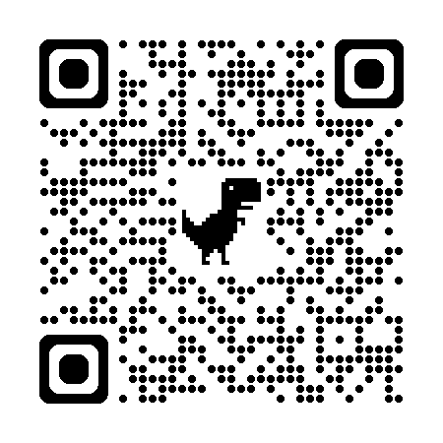

NMRA <https://www.nmra.org/index-nmra-standards-and-recommended-practices>

